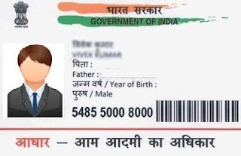

Gkdig

N 689848669453

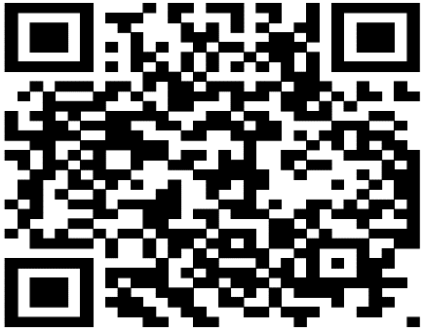

[This Photo](http://stackoverflow.com/questions/37164384/why-this-qr-code-is-difficult-to-read) by Unknown Author is licensed under [CC BY-SA](https://creativecommons.org/licenses/by-sa/3.0/)

Sonam

**Father: Hari Shan**

kar

DOB: 24/09/2005

Female

266497831234